DRONE FOR MILITARY PURPOSE

A FINAL YEAR PROJECT REPORT

*SUBMITTED BY:*

SARANSH RA1611004020388

NILAY MISHRA RA1611004020339

SANKALP YADAV RA1611004020392

SHAIL JHA RA1611004020342

ELECTRONICS AND COMMUNICATION ENGINEERING



SRM INSTITUTE OF SCIENCE AND TECHNOLOGY RAMAPURAM

November 2018

**SRM INSTITUTE OF SCIENCE AND TECHNOLOGY**

RAMAPURAM

**BONAFIDE CERTIFICATE**

Certified that this final year project report **“DRONE FOR MILITARY PURPOSE ”**is the **bonafide work of “SANKALP(RA1611004020392), SARANSH(RA1611004020388),**

**SHAIL(RA1611004020342), NILAY(RA1611004020339),** who carried out the project work under my supervision.

SIGNATURE

**Mrs. G.PRIYA**

Assistant Professor (Sr.G) Department Of Electronics and

Communication Engineering

SRM Institute of Science and Technology Ramapuram

Chennai-600089

SIGNATURE

**Dr.Phani Kumar Polasi Ph.D** Professor and Head Department Of Electronics and Communication

Engineering

SRM Institute of Science and Technology Ramapuram

Chennai-600089

**INTERNAL EXAMINER- I INTERNAL EXAMINER-II**

**ACKNOWLEDGEMENT**

We are place on regard our deep sense of gratitude to our beloved Chancellor to **Dr.T.R.PACHAMUTHU,** for providing us with the requisite infrastructure throughout the course.

We take the opportunity to extend our hearty thanks to our Chairman,

**Dr.R.SHIVAKUMAR** for his constant encouragement.

We take the opportunity to extend our hearty thanks to our Dean, **Dr.V.SUBBIAH BHARATHI** for his constant encouragement.

We convey our sincere thanks to our Vice Principal (Academic), **Dr. K.N. SRINIVAS** for his interest and support throughout this project.

We take the privilege to extend our hearty thanks to the Head of the Department **Dr. PHANI KUMAR POLASI,** for his suggestions, support and encouragement towards the completion of the project with perfection.

We express our heartfelt thanks to our faculty coordinator **Mrs.T.Ramya** Assistant Professor (O.G) – Department of Electronics and Communication Engineering for his sustained encouragement, consecutive criticisms and Support throughout this project work.

We convey our sincere thanks to our Guide, **Mrs.Annapoorani,** Assistant Professor (Sr.G) – Department of Electronics and Communication Engineering for his interest and guidance throughout this project work.

Abstract

A quadcopter can achieve vertical ﬂight in a stable manner and be used to monitor or collect data in a speciﬁc region such as Loading a mass. Technological advances have reduced the cost and increase the performance of the low power microcontrollers that allowed the general public to develop their own quadcopter. The goal of this project is to build, modify, and improve an existing quadcopter kit to obtain stable ﬂight, gather and store GPS data, and perform autocommands, such as auto-landing. The project used an Aeroquad quadcopter kit that included a frame, motors, electronic speed controllers, Arduino Mega development board, and sensor boards and used with the provided Aeroquad software. Batteries, a transmitter, a receiver, a GPS module, and a micro SD card adaptor were interfaced with the kit. The aeroquad software was modiﬁed to properly interface the components with the quadcopter kit. Individual components were tested and veriﬁed to work properly. Calibration and tuning of the PID controller was done to obtain proper stabilization on each axis using custom PID test benches. Currently, the quadcopter can properly stabilize itself, determine its GPS location, and store and log data. Most of the goals in this project have been achieved, resulting in a stable and maneuverable quadcopter.

**KEYWORDS :-** Drone/Quadcopter**,** Transmitter & Remote**,** Propellers**,** Electric Motors**,** Battery

**Table of Contents**

Chapter 1:- Introduction… 1

Chapter 2:- Literature Review 3

* 1. History 3
  2. Current Development… 4

Chapter 3:- Proposed System 7

* 1. Materials 7
  2. Specifications And Methodology
     1. Electronic Assistance 9
     2. Motors 9
     3. Technical Specifications 10

**CHAPTER 1**

**INTRODUCTION**

A Drone or Quadcopter is a Vehicles have large potential for performing tasks that are dangerous or very costly for humans. Examples are the inspection of high structures, humanitarian purposes or search-and-rescue missions. One speciﬁc type of Drone is becoming increasingly more popular lately: the quadcopter (Fig. 1.1). When visiting large events or parties, professional quadcopters can be seen that are used to capture video for promotional or surveillance purposes.

Recreational use is increasing as well: for less than 50 Euros a small remote controlled quadcopter can be bought to ﬂy around in your living room or garden. In these situations the quadcopter is usually in free ﬂight. There is no physical contact between the surroundings and the quad copter and no cooperation between the quadcopters If would have the capabilities to collaborate the number of possibilities grows even further. For example, a group of Drone would be able to efﬁciently and autonomously search a missing person in a large area by sharing data between. Or, the combined load capacity of a group of quad copters can be used to deliver medicine in remote areas. This bachelor thesis focuses on the use of a commercially available quadcopter platform, the.Drone, to perform a task that requires physical collaboration and interaction: moving a mass. In this way a clear interaction between the quadcopters and their surroundings is present. As preliminary step towards the view of collaborating aerial robots the choice was made to perform this task in an indoor scenario where position feedback is present. Starting off with position control, additional controller logic can be implemented to counteract the forces imposed by a mass connected to the quadcopter. The choice is made for the Drone, a generalized approach is chosen where possible to encourage reuse of this research’s outcome and deliverables.

A helicopter is a ﬂying vehicle which uses rapidly spinning rotors to push air downwards,thus creating a thrust force keeping the helicopter aloft. Conventional helicopters have two rotors. These can be arranged as two coplanar rotors both providing upwards thrust, but spinning in opposite directions (in order to balance the torques exerted upon the body of the helicopter).

**CHAPTER 2**

**LITERATURE REVIEW**

**2.1.History**

**1)Oehmichen (1920)**

[Etienne Oehmichen](http://en.wikipedia.org/wiki/Etienne_Oehmichen) experimented with rotorcraft designs in the 1920s. (Fig.2.1) among the six designs he tried, his helicopter No.2 had four rotors and eight propellers, all driven by a single engine. The Oehmichen No.2 used a steel-tube frame, with two-bladed rotors at the ends of the four arms. The angle of these blades could be varied by warping. Five of the propellers, spinning in the horizontal plane, stabilized the machine laterally. Another propeller was mounted at the nose for steering. The remaining pair of propellers were for forward propulsion.

The aircraft exhibited a considerable degree of stability and controllability for its time, and made more than a thousand test flights during the middle 1920s. By 1923 it was able to remain airborne for several minutes at a time, and on April 14, 1924 it established the first-ever FAI distance record for helicopters of 360 m (390 yd). It demonstrated the ability to complete a circular course and later, it completed the first 1 kilometer (0.62 mi) closed-circuit flight by a rotorcraft.

### **2)** [**De Bothezat helicopter**](http://en.wikipedia.org/wiki/De_Bothezat_helicopter) (1922)

[Dr. George de Bothezat](http://en.wikipedia.org/wiki/George_de_Bothezat) and Ivan Jerome developed this aircraft, (Fig. 2.2 ) with six bladed rotors at the end of an X-shaped structure. Two small propellers with variable pitch were used for thrust and yaw control. The vehicle used collective pitch control. Built by the US Air Service, it made its first flight in October 1922. About 100 flights were made by the end of 1923. The highest it ever reached was about 5 m (16 ft 5 in). Although demonstrating feasibility, it was underpowered, unresponsive, mechanically complex and susceptible to reliability problems. Pilot workload was too high during hover to attempt lateral motion.

**3)[Convertawings Model A Quadrotor](http://en.wikipedia.org/w/index.php?title=Convertawings_Model_A_Quadrotor&action=edit&redlink=1) (1956)**

This unique helicopter was intended to be the prototype for a line of much larger civil and military quadrotor helicopters. The design featured two engines driving four rotors through a system of v belts. (Fig. 2.3) No tail rotor was needed and control was obtained by varying the thrust between rotors.[5] Flown successfully many times in the mid-1950s, this helicopter proved the quadrotor design and it was also the first four-rotor helicopter to demonstrate successful forward flight. Due to a lack of orders for commercial or military versions however, the project was terminated. Convert a wings proposed a Model E that would have a maximum weight of 42,000 lb (19 t) with a payload of 10,900 lb (4.9 t) over 300 miles and at up to 173 mph (278 km/h).

### **4)**[**Curtiss-Wright VZ-7**](http://en.wikipedia.org/wiki/Curtiss-Wright_VZ-7) **(1958)**

The Curtiss-Wright VZ-7 was a [VTOL](http://en.wikipedia.org/wiki/VTOL) aircraft designed by the [Curtiss-Wright](http://en.wikipedia.org/wiki/Curtiss-Wright) company for the US Army. The VZ-7 was controlled by changing the thrust of each of the four propellers. (Fig.2.4) [AR.Drone](http://en.wikipedia.org/wiki/Parrot_AR.Drone) is a small [radio controlled](http://en.wikipedia.org/wiki/Radio_controlled) quadcopter with cameras attached to it built by [Parrot SA,](http://en.wikipedia.org/wiki/Parrot_(company)) designed to be controllable with by smartphones or tablet devices. [Nixie](http://en.wikipedia.org/wiki/Nixie_drone) is a small camera- equipped drone that can be worn as a wrist band.(6)

* + - Had 4 rotors and 8 propellers all driven by one motor
    - Over 1000 Successful flights
    - First recorded FAI distance record of 360m in 1924 for a helicopter
    - Very Stable for the Time
    - Designed by Etienne Oemichen
  1. **Current Developments**

In the past 10 years many small quadcopters have entered the market that include the DJI Phantom and Parrot AR Drone. This new breed of quadcopters are cheap, lightweight. In the 20th Century, military research precipitated many widely used technological innovations. Surveillance satellites enabled the GPS-system, and defence researchers developed the information swapping protocols that are fundamental to the Internet. Drone fall into a similar category. Designed initially for reconnaissance purposes, their para-military and commercial development was often out of sight of the public.

**Military UAVs** - **from the Civil War to the Middle East conflicts:**

The Oxford English Dictionary describes drones as **'*a remote-less controlled piloted aircraft or missile'.***

Understood in such sense, drones came into first use after World War II when unmanned jets, such as the [Ryan Firebee](http://www.nationalmuseum.af.mil/factsheets/factsheet.asp?id=3363) (a [documentary](http://www.youtube.com/watch?v=X3amdRhNjK0) about the Firebee and the [use of early drones in the Vietnam](http://gizmodo.com/5893287/americas-killer-drones-of-the-vietnam-war) [War](http://gizmodo.com/5893287/americas-killer-drones-of-the-vietnam-war)), started field operation. Since then, the number of drones in military use increased substantially enough that the New York Time decided to refer to it as a [new paradigm for warfare.](http://www.nytimes.com/2011/06/20/world/20drones.html?pagewanted=all&_r=0)

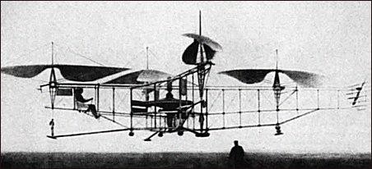

Fig. 2.1 : 1920 - Oemichen

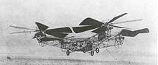

Fig. 2.2 : De Bothezat helicopter, 1923 photo

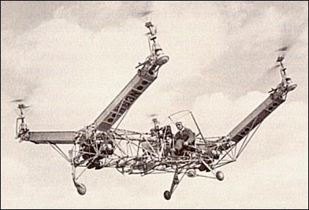

Fig. 2.3 : 1956 – Convert a wings Model A Quadcopter

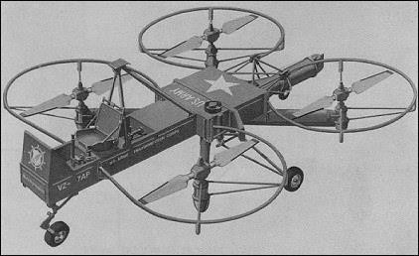

Fig. 2.4 : 1958 - Curtis Wright VZ-

**CHAPTER 3**

**PROPOSED SYSTEM**

* 1. **Materials-**

For someone new to the multirotor hobby, putting together our first quadcopter parts list can be extremely daunting. Trying to figure out what to buy and what parts will work together is tough, especially for people who don’t come from a background in radio controlled planes or helicopters. Forums are packed with people who want to build a quadcopter but don’t know where to start. It can be frustrating trying to sort through the thousands of posts on forums and blogs and figure out what to do.

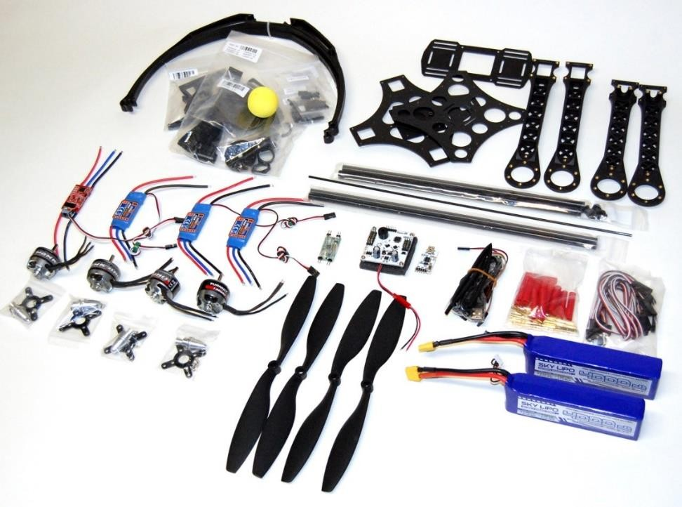

Fig. 3.1 : All Parts

We’ve heard from a lot of readers who are in similar positions and this post is designed to spell out exactly what you need for your first quadcopter build. While we will recommend a complete list of specific parts that we have used and tested for a complete quadcopter build, the main purpose of this post is to provide a general overview of the parts needed to build a quadcopter. Here’s what you’ll need:

|  |  |  |
| --- | --- | --- |
| **Serial No.** | **Parts** | **Material** |
| 1 | Frame | Carbon Frame |
| 2 | Brushless Motor | 70,200 rpm |
| 4 | Flight Control Board | Circuit plate |
| 5 | Radio transmitter and receiver | Electrical Remote |
| 6 | Propeller x4 (2 clockwise and 2 counter-  clockwise) | Flexible plastic material |
| 7 | Battery & Charger & Microcontroller. |  |

Table no. 3.1 Parts & Materials

**3.2. SPECIFICATIONS AND METHODOLOGY :-**

A thermal vision drone which can do a flying overview and to check the nearness or nonattendance of foes. This automaton can enable the military to troop to design in like manner and can likewise be useful for an unexpected assault. The automaton is light weighted and quick enough to run and stow away. It runs at the speed of 250km/hr. The automation has the thermal vision camera which can recognize the heat mark of the human or creatures along these lines it can likewise work under the low light. The automaton is comprised of carbon fibre body which makes the automaton light. It has 4 brushless engines with 4 cutting edge propeller, electronic speed controller which directs the speed of the engine, flight controller which oversees all the parts of the drone,1 remote used to control the automaton, 1 recipient which takes the sign from the remote, 1 warm vision camera, clean flight which is a product through which we can change settings of the automaton and force appropriation and battery which is the force wellspring of the automation.

Following are the segments utilized for building the automaton:

**Casing:** Frame is a significant segment that holds all the segments together. It ought to be unbending and sufficiently able to withstand all the heaps. Casings are generally made by Glass fiber or Carbon fiber. Examples of frame –

Propeller: Choosing your propeller is the significant factor without the propeller your automaton won't produce lift. Propellers are chosen dependent on two things Pitch and Diameter. High pitch and Low Diameter propellers are utilized for building hustling rambles. It will make your automaton travel quicker.

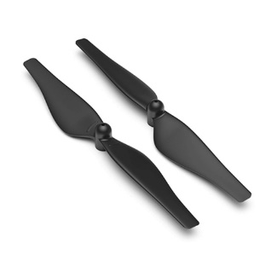 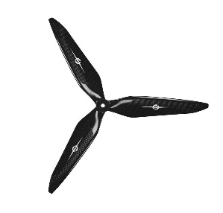

**Brushless Motors:** These engines have higher RPM when contrasted with traditional Brushed Motors. Brushless engines are chosen dependent on the KV rating of the engine. KV rating indicates the RPM of the engine. For instance, 2000KV methods 2000 RPM for every volt. Higher KV rating engines are chosen for Racing rambles.

**Electronic Speed Controller**: It is utilized to control the speed of the engine. ESC is chosen dependent on the amps draw required by the engines.

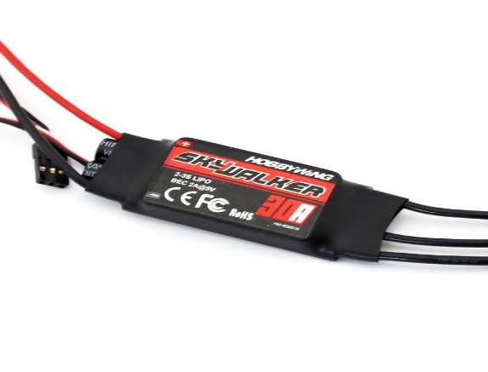

**Power Distribution Board:** PDB's are regularly a neglected zone of multirotor ramble building, principally in light of the fact that they are genuinely basic yet notwithstanding this they are a significant piece of your automaton and on the offchance that youdon't pick the correct one you could wind up loosing your automaton. As the name recommends, a PDB appropriate the force on your automaton, and gives a perfect and clean method for interfacing your battery to the entirety of your ESC's on your airplane. A PDB has positive cushions/terminals which are totally associated and negative terminals/cushions which are completely associated. Along these lines when you patch the entirety of the red wires from your ESC's and battery to the positive cushions on the PDB, and the dark wires to all the negative cushions, they will all get associated so your battery can give capacity to the entirety of your ESC's as appeared in the picture beneath.

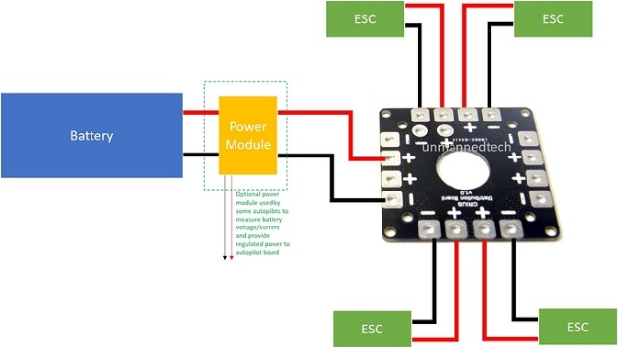

Radio Receivers: A Radio Receiver is the device capable of receiving commands from the Radio Transmitter, interpreting the signal via the ﬂight controller where those commands are converted into speciﬁc actions controlling the aircraft.

**Remote Control**: A radio control framework is comprised of two elements ,the transmitter you grasp and the recipient you puts inside your drone .Dramatically streamlining things here,your ramble transmitter will peruse your stick inputs and send them through the air to your collector in close to genuine time. Once the beneficiary has this data it gives it to your automatons flight controller which makes the automaton move accordingly .The radio will have four separate channels for every heading on the sticks alongside some additional ones for any assistant switches it might have.

**Throttle, Yaw , Roll & Pitch:**

To fly a multicopter, you need at least 4 channels. On the grounds that there are 4 motors and there are 4 controls you should use to keep the quadcopter flying:

*Throttle (how quick the engines are turning)

*Pitch (tilting the multicopter advances and in reverse)

*Roll (tilting the multicopter to either side)

*Yaw (rotating the multicopter on its pivot)

Binding TX and RX: Authoritative of TX and RX just should be done once.You will lose the quandary when you change the firmware of either the "TX module" or RX, or in the wake of restricting the RX to an alternate TX.The restricting procedure is normally straight forward however may vary from model to model,please allude to the manual.

Note that you can tie different recipients to the equivalent TX, so you can control various automatons utilizing the equivalent transmitter. But you can just tie the RX to one TX.

**Range:** There are numerous components that can influence the scope of your RC connect. View gives you the most ideal sign, obstructions between your TX and RX can fundamentally decrease the range Transmitter yield power, higher force implies longer range yet be careful with lawful constraint Beneficiary affectability, the more delicate the better the range Collector decent variety, some "full range" RX offers two radio wires for assorted variety Reception apparatus arrangement

Ordinarily, the best 2.4Ghz radio may give you 300m to about 1.5Km territory. On the off chance that you need to go further with a dependable sign, you will need to put resources into "long range" RF frameworks. For instance, the TBS Crossfire or Frisky R9M that use lower recurrence groups.

You will burn through battery vitality and automaton flight time with less productive engines. To get a higher push, the engine should draw increasingly current. The best mix for an automaton engine is high pushed with low current draw. Wasteful engines produce excessively little push, or utilize an excess of current.

**Drone Motor Efficiency:** Electric engine effectiveness is the proportion between the mechanical force yield and electrical force input. The mechanical force yield is resolved dependent on the torque and speed required and the electrical force is controlled by the voltage and flow provided to the engine. Be that as it may, the engine proficiency isn't steady over the whole pushed profile. Some automaton engines might be effective at a lower throttle, however begin losing effectiveness at higher flows as it moves toward its most extreme cut off.

The recipe utilized for estimation of engine proficiency is "push/power utilized in W"; its general unit becomes g/W. presently, in the event that you have higher estimation of g/W rating that implies your engine is increasingly productive and it will help ramble in longer flights. Experts suggest picking an engine that has proficiency esteem close around 7 or over this.

**Drone Sizing:** The frame is 500mm square, and that the drone weighs 1587 grams, which includes a 3-cell 5000 mAh LiPo battery. When sizing a drone motor, you want to have a minimum thrust-to-weight ratio of 2:1 at full throttle. For longer flight, we will use a 3:1 ratio. Knowing the weight of the drone, then each drone motor needs to generate 1190 grams of thrust (1550 x 3 / 4).2204 and 2205 are common motors that are used on quadcopters. A good propeller matching for three motors are:

*2600kv and higher motors for 4 propellers

*2300-2600 kv for 5 propellers

*2300 kv and lower for 6 propellers

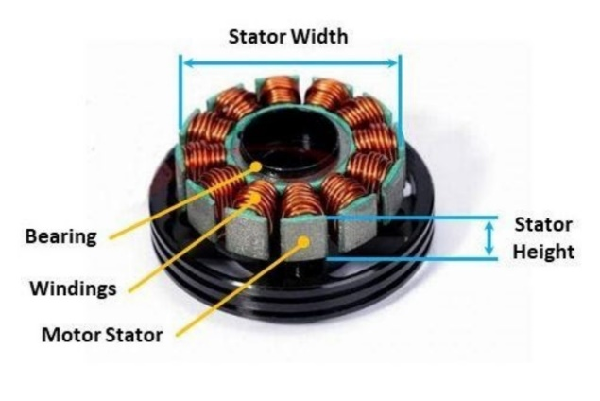

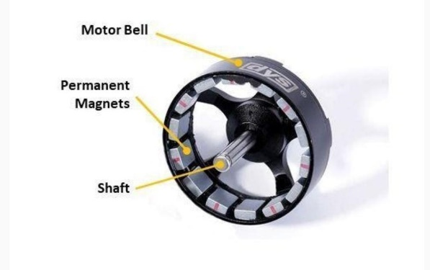

**CleanFlight :** Cleanflight can be utilized on multirotor airplane and fixed-wing airplane, it bolsters an assortment for shapes and engine checks, not restricted to quadcopters, hexacopters, octocopters, tricopters and planes. Cleanflight is Open-Source flight controller programming which is 32-bit form of the first 8-bit MultiWii code.

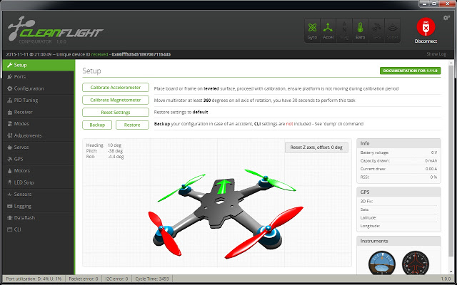

**Thermal camera** : A thermographic camera (likewise called an infrared camera or warm imaging camera or warm imager) is a gadget that makes a picture utilizing infrared radiation, like a typical camera that frames a picture utilizing noticeable light. Rather than the 400–700 nanometre scope of the unmistakable light camera, infrared cameras are delicate to wavelengths from around 1,000 nm (1 μm) to around 14,000 nm (14 μm). The specialty of catching and breaking down the information they give is called thermography.

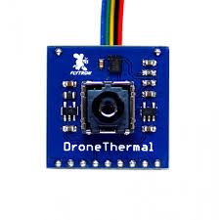

So as to test the capacity of minimal effort warm infrared sensor to recognize little airborne UAVs, we flew three UAVs of various sizes and setups over a 100 m long test track (Figure 1). The objective was to decide at what separation the UAVs could be recognized without attempting to distinguish them. UAVs were flown at roughly 10 m over the ground level and at a consistent speed of around 2 m/s. The test was performed on a generally warm summer night (26 °C) against an unmistakable sky and with no wind. The territory of the polygon was green, without huge warm sources and with no wellsprings of light. The test was performed more than

2 hours after nautical sundown



31

°

diagonal

FOV



4

m



Fig

.

1

. Test Track



100

m

The sensor was appended to the breakout board intended to encourage simpler association of the sensor to the PC. The entire breakout board was then encased in a defensive case and associated with the Raspberry PI 3 through GPIO pins

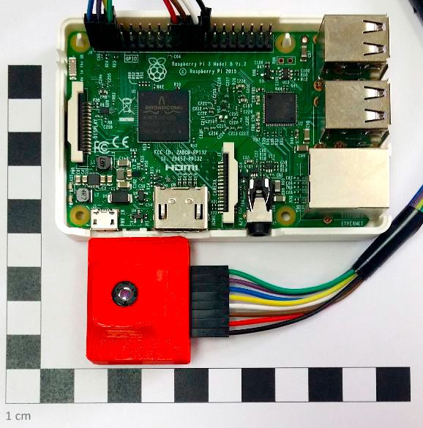

**Quadcopter Battery Types :** The two fundamental potential options to LiPo batteries are Nickel Metal Hydride (NiMH) and Nickel Cadmium (NiCd) batteries. LiPo (lithium polymer) batteries offer huge preferences over different kinds of batteries. The points of interest that LiPo batteries offer over NiCd and NiMH batteries are:

1. LiPo batteries have higher limits which permit them to hold more power

2. LiPo batteries have higher release rates permitting quicker force move

3. LiPo batteries are lighter and can be made in various shapes and sizes

**LiPo Battery Drawbacks :** 1. LiPo batteries have a shorter life expectancy of around 300 to 400 cycles, when contrasted with NiMH and NiCd batteries

2. On the off chance that the battery gets punctured and vents into the air, there is a likelihood this could bring about a fire

3. Some additional consideration should be taken while charging, releasing, or putting away LiPo batteries.

**Quadcopter Battery Voltage and Cell Count :** A solitary LiPo cell has an ostensible voltage of 3.7V. To explain, the ostensible voltage is around the normal of the full charge of 4.2V/cell, and the base safe charge of 3.0 V/cell. For the scientifically disposed peruser, you will see that 3.7V/cell isn't generally the normal of those two qualities, yet this is the thing that the battery business utilizes as an ostensible worth.

Ostensible LiPo Battery Voltage = 3.7 V/cell The absolute voltage of a battery is controlled by the quantity of cells. To ascertain the complete voltage, you take the quantity of cells in arrangement, and duplicate by 3.7V. So a 2S battery pack will have 2 cells in arrangement, so its all out voltage is 2 x 3.7 = 7.4V. A 3S battery has three cells in arrangement, so its voltage is 11.1V.

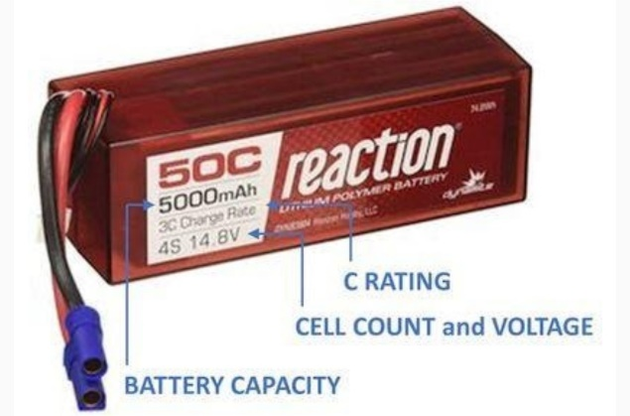

The voltage of a quadcopter battery pack will decide how quick your propellers turn. Brushless engines have a rating assigned in units of kV, which adequately implies RPM per volt. So the more voltage you have accessible, the higher the most extreme RPM of your quadcopter's propellers. This can bring about progressively unique dexterity, and quicker speeds. Quadcopter

**Battery Safety rules :**

*Just use chargers intended for LiPo batteries. They have worked in wellbeing highlights to help maintaining a strategic distance from issues.

*Continuously screen LiPo batteries that are being charged.

*Keep a fire dousing gadget (quencher or sand) close by in the event that things turn out badly.

*Utilize a LiPo charging pack. These are intended to contain the blazes should a battery be broken. These packs are cheap and can end up being a lifeline.

*On the off chance that you crash, investigate your battery since it might have been harmed.

*A protruding LiPo is a dangerous situation. Like a spring of gushing lava, unsafe gases and vapor are prepared to blast out of your battery. The poisonous materials radiating from a LiPo battery can touch off when in contact with air.

*Never cut a LiPo battery, it will definitely burst into flames.

*Charge you LiPo batteries in an all around ventilated region and on a fire safe surface.

**Raspberry – pi Connection :-**

to use the raspberry pi first we need to set up the module before using it.

1)format the sd card.

2)burn the raspbian os into the sd card with the help of a win32 disk imager

3)install the sdcard into the raspberry pi and then connect the ethernet cable and power supply.

4)open the Putty software and type the IP address of the raspberry pi and click open. IP address of the raspberry pi can be find through Advance IP scanner or in the network setting in the computer.

**Camera model to Raspberry -pi**

1)connect the cable of the camera into the slot of the raspberry pi module which situated between the HDMI port and ethernet port. The blue color of the cable of the camera should be facing towards the ethernet port.

2)connect the raspberry pi to the power source(here I have connected to the laptop ). Open the Putty software and connect to your raspberry pi through IP address.

3)type the command "sudo apt get-update" and "sudo apt- upgrade" (just in case if the camera option is not listed this command will help your raspberry os up-to-date).

4)type "sudo raspi-config" a list of options will appear, select camera and click finish. Reboot the raspberry pi.

5) type "raspistill -o name.jpg" and type "raspivid -o name.h264".